Duration or Time Difference

Definition
# Source: AI Source: Provided by: [Data Path: Persons Table -> ID Column: 1, Name_En Column: Motasem Essam] -> From: [Chatgpt (GPT‑5 Mini)] on [12/10/2025]
Duration or Time Difference is a date/time transformation technique that calculates the difference between two dates or timestamps. It is commonly used to measure elapsed time, intervals, or durations between events.

Key Idea
# Source: AI Source: Provided by: [Data Path: Persons Table -> ID Column: 1, Name_En Column: Motasem Essam] -> From: [Chatgpt (GPT‑5 Mini)] on [12/10/2025]
Instead of just using raw dates or times, the difference between two temporal values can provide meaningful information, such as:
- Time taken to complete a task
- Customer response time
- Duration between purchases
This numeric feature can be directly used in data analysis or machine learning models.

How It Works
# Source: AI Source: Provided by: [Data Path: Persons Table -> ID Column: 1, Name_En Column: Motasem Essam] -> From: [Chatgpt (GPT‑5 Mini)] on [12/10/2025]
- Identify start and end dates or timestamps.
- Subtract the start from the end to get the duration.
- Express the duration in a suitable unit: days, hours, minutes, or seconds.

Example 1: Duration in Days
# Source: AI Source: Provided by: [Data Path: Persons Table -> ID Column: 1, Name_En Column: Motasem Essam] -> From: [Chatgpt (GPT‑5 Mini)] on [12/10/2025]
Original dataset:
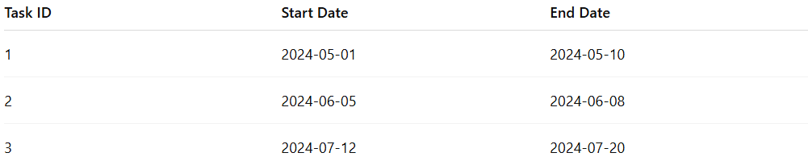
Task ID | Start Date | End Date
1 | 2024-05-01 | 2024-05-10
2 | 2024-06-05 | 2024-06-08
3 | 2024-07-12 | 2024-07-20
Duration (days):
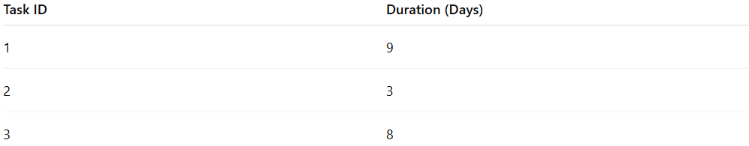
Task ID | Duration (Days)
1 | 9
2 | 3
3 | 8

Example 2: Duration in Hours
# Source: AI Source: Provided by: [Data Path: Persons Table -> ID Column: 1, Name_En Column: Motasem Essam] -> From: [Chatgpt (GPT‑5 Mini)] on [12/10/2025]
Original dataset:
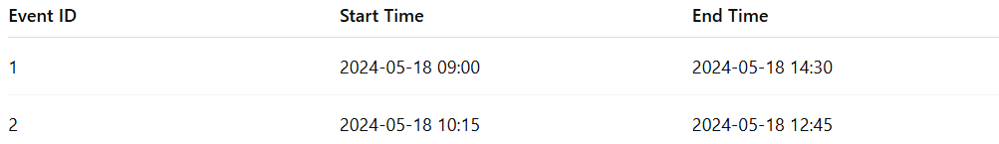
Event ID | Start Time | End Time
1 | 2024-05-18 09:00 | 2024-05-18 14:30
2 | 2024-05-18 10:15 | 2024-05-18 12:45
Duration (hours):
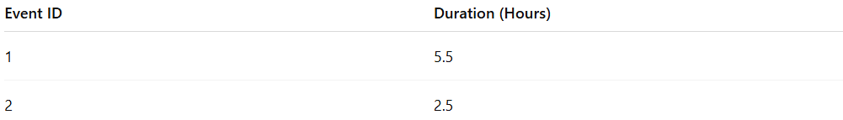
Event ID | Duration (Hours)
1 | 5.5
2 | 2.5

Advantages
# Source: AI Source: Provided by: [Data Path: Persons Table -> ID Column: 1, Name_En Column: Motasem Essam] -> From: [Chatgpt (GPT‑5 Mini)] on [12/10/2025]
- Provides direct numeric insight into time intervals
- Useful for predictive modeling, e.g., predicting task completion or customer response
- Captures temporal patterns that raw dates or times cannot

Disadvantages
# Source: AI Source: Provided by: [Data Path: Persons Table -> ID Column: 1, Name_En Column: Motasem Essam] -> From: [Chatgpt (GPT‑5 Mini)] on [12/10/2025]
- Requires both start and end timestamps
- May require handling missing or inconsistent values
- Choice of unit (days, hours, minutes) may affect analysis

